Software Engineering Project: Ecommerce Web Application

Kassie Garcia (Writer / Editor), Nkeiruka Nwogu, James Le, Azra Al Rabeeah (Main Writer), Walter Schmidt, and Herman Garza, Members of Group 2, CS-3773-002 Spring 2022

**Abstract:-** Ecommerce Websites are great for businesses, big and small, to allow their customers to buy / sell goods, services, and products over the internet rather than at a physical store location. In this project, we have developed an ecommerce web application for a coffee company named *Hug With Mug*. At Hug With Mug, the goal is to sell various coffee related items to customers from all over the world. The Hug With Mug web application offers customer functionality such as making an account, displaying best seller items, adding an item to a wish list, adding an item to a shopping cart, placing an order, etc. The Hug With Mug web application also offers admin functionality for the Hug With Mug store owner. This functionality includes viewing currently placed orders, adding/deleting/modifying products for sale, adding/modifying coupon codes, and much more!

This application was designed by us as a group to not only help customers buy and browse Hug With Mug products, but also to help the store owner (admin) to manage the website and the orders with ease.

**Part 1a: Group Workflow:-** We started out as a group unsure of how to go about this project. Many of us did not have any web development experience prior to taking this course and started off without a clue as to what developing a website entailed. Our project manager, Kassie Garcia, was chosen to lead our group, as it was discussed it would be best to have the student with development experience manage the project.

Since the beginning of February, our project manager has planned out sprints for every 2-week period. These sprints were planned in documents, which consisted of the group’s overall goal for the 2-week period, as well as a list of the product backlog items to be worked on by the front-end & back-end developers. The group met every Wednesday of the week (over Discord voice channel) to discuss the product backlog items to be implemented, as well as any updates, questions, and issues we were going through. If any of the backlog items from the sprint were not finished, it would then get added as a higher priority item to be implemented in the next sprint.

At first, we encountered a few difficulties in deciding how to best develop the web application. We considered using WordPress but was unsure as to how to implement the admin backend functionality when WordPress itself acted as the backend. We considered using AngularJS but found the framework to be more overwhelming than it was helpful. Eventually, we landed on **LEMP**.

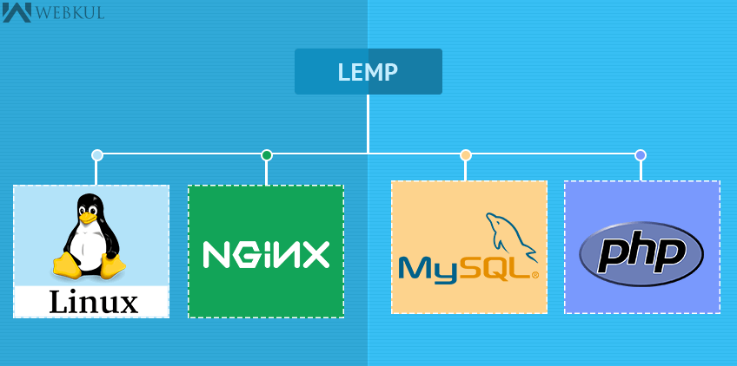**LEMP** (**L**-Linux **E**-Nginx **M**-MySQL **P**-PHP) is the stack we used to develop our web application.

The **LEMP** stack is an open-source web development stack which is used to serve dynamic web pages and web applications. This means that for our project, we used a Linux operating system with a Nginx web server. The data for our project was stored in a MySQL database and the dynamic processing / functionality was implemented with PHP.

Most of the functionality was implemented with the language PHP, while we did use the combination of PHP/SQL to interact with our database, and we also used JavaScript for some client-slide features.

To publicly host the website, we used an Amazon EC2 Instance to host our application on the Amazon Web Services Infrastructure. This means that only one of us (the project manager) made an EC2 instance, while everyone else worked on the project from their own local environments. To share the project and keep the EC2 instance updated, we would push / pull the project files and the MySQL database file from / to our GitHub repository. This repository served as our version control software to collaborate as a group.

**Part 1b: Group Project Roles:-**

Overall, here are the roles we had first assigned in the beginning of the semester:

Kassie Garcia- Project Manager, DB Management

Nkeiruka Nwogu and James Le- Front-End Development

Azra Al Rabeeah- Project Write Up, Logo Design

Walter Schmidt and Herman Garza- Back-End Development

However, these roles changed drastically as time progressed, and some members ended up contributing little to no work to the project. Here are the roles which reflect the actual contributions:

Kassie Garcia- Project Manager (management, write-up, and presentation slides), Main Project Developer for both front and back-end work

James Le- Worked on a document consisting of a list of products for sale

Nkeiruka Nwogu- Worked on the same document, designed some of our product images, as well as worked on making the UI/UX responsive and reactive.

Azra Al Rabeeah- Project Write Up

Walter Schmidt- No code contributed

Herman Garza- Worked on the search functionality

As this report continues, we will discuss these contributions in greater detail, as well as who exactly contributed to the work being discussed. This is to give proper credit for the work done.

**Part 2: The Creation of Hug With Mug:-** In our first sprint, we decided, as a group, to base our ecommerce website on a made-up coffee company named *Hug With Mug*. We brainstormed items to sell, and landed on selling items such as coffee bags, tea, mugs, tote bags, and t-shirts. We decided that in order to have our UI reflect the theme of our company, it should then consist of a clean, simple look with mainly white, gray, brown, and green colors. We also decided that we will need to gather at least 15 product images to sell on the website, as well as creating any images necessary that contribute to the website design. It took some effort to collect these as images, and we sought to collect ones that best suited our store's concept. We also designed our own one-of-a-kind apparel and display photos that highlight the items we now offer for sale.

Here is the logo image, designed by Nkeiruka Nwogu, as well as some of the products curated by both Nkeiruka and James Le:



**Part 3: UI/UX Design:-** As discussed in part 2, we decided that the UI theme should be kept simple and natural in terms of design elements. And we focused on using mainly white, gray, brown, and green colors. For the UI, we used **bootstrap** / other CSS styles to design our website. This means that many of the style classes we used are already existing classes offered in bootstrap. We decided to use bootstrap because it is typically used to make web applications responsive and reactive, which was a big goal for us. This meant our website will then look good on a variety of screen sizes- which would ensure the usability and satisfaction of our website.

However, we had some difficulty using bootstrap for our design. Some design elements, such as forms or the navigation bar, were easily implemented with bootstrap and could be easily scalable to any window size. But when it came to our product blocks (the blocks which display the product image), we could not get them to be as scalable as intended without them looking extremely “wonky” and out of place from their style grid. However, developer Nkeiruka Nwogu made her best efforts to make the website responsive and reactive from the styles and design Kassie Garcia initially implemented.

**Part 4a: Functionality:-** As discussed in our abstract, our goal with developing our web application was to help customers buy and browse Hug With Mug products, and to help the store owner (admin) to manage the website and the orders with ease. In **Part 4b,** we will discuss the **User Experience**. This User Experience will consist of the details surrounding the functionality and web pages implemented for customers to use. In **Part 4c**, we will discuss the **Admin Experience.** This Admin Experience will consist of the details surrounding the functionality and web pages implemented for the admin user (store owner) to use.

Note here, that *all* the functionality we will discuss was implemented by Kassie Garcia. Except for the search functionality, which was implemented by Herman Garza.

**Part 4b: Functionality: User Experience:-**

**4b.01.01: Registering a New User**

When a user would like to create a new account, they can do so by clicking on the “register” tab on the top left of the homepage or by clicking the “Register Here!” link in our login page. Our website will take a user’s full name, unique username, unique email, password, mobile phone number, and home address. In our code, we cross check with our database table customers and ensure there is not a user that already exists for the given username or email.

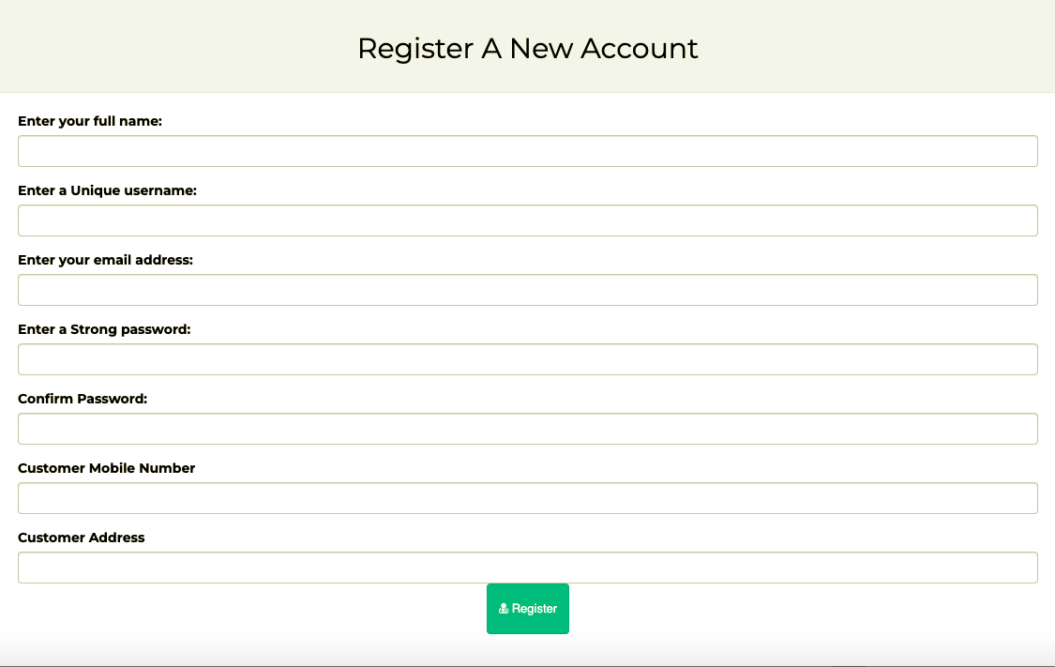If all is good to go, we will update our customer database table with the entered information, encrypt the password for safety concerns, and inform the user that they have been registered successfully. If there was an error, the user will be redirected to try registering again.

Snippet of our *registration form*, which takes in all the user input for creating a Hug With Mug User

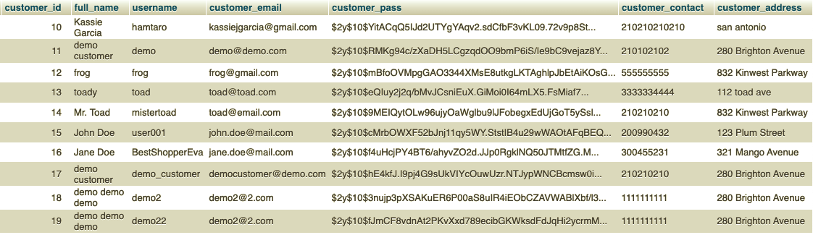

Snippet from our *customers* database table, which stores all the information on a Hug With Mug User

**4b.02.01: Login an Existing User**

If a user would like to sign in with an existing account, they can do so by clicking on the “sign in” link on the top left of the homepage. Users may even get redirected to the sign in page if they are trying to add a product to a wish list, or if they are trying to checkout without signing in. In our sign in page, we take in the user's username and their password, then we cross check with our database table customers to ensure a given user exists for that username and that the password given matches the encrypted one in the database.

If there was an error, the user will be redirected to try logging in again. If all is good to go, a session is created for that user, and they will be redirected to their account page. Once signed in, the user can now access certain features (i.e., checkout, wish list, account page, etc.)

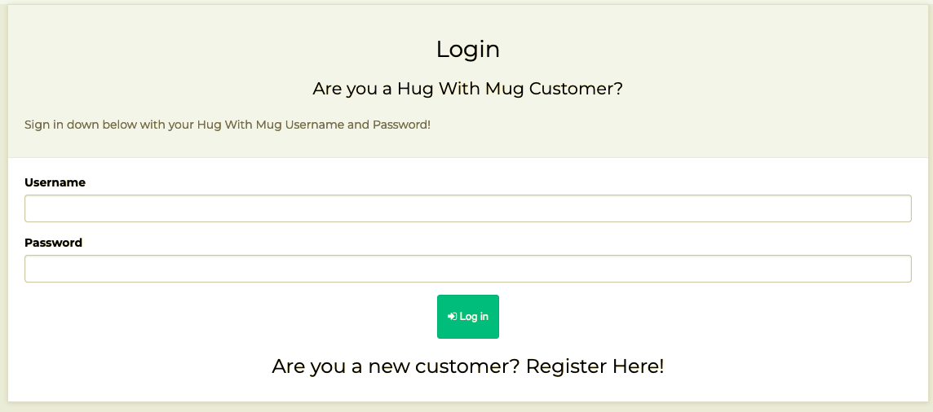

Snippet of our *login form*, which takes in a username and password from user input

**4b.03.01: Home Page**

Our homepage displays a slideshow consisting of three images showcasing the products that we sell. Below this, we show our “bestsellers”- which consists of 8 products shown in display blocks. These blocks include the first product image, a banner if a product is on sale or not, a view details button, and an add to cart button which links the user to the product display page.

Gif of *home* *page*, which displays 3 featured images, as well as 8 best-selling items

**4b.04.01: Shop All page**

The shop page displays all the products we have stored in our products database table. These products are all displayed in blocks. These blocks include the first product image, a banner if a product is on sale or not, a view details button, and an add to cart button which links the user to the product display page. There are 8 products to a page. The user can also switch back and forth between pages via the paginator to view all the products.

**4b.04.02: Coffee / Tea / Merch Pages**

They are all simply the shop page, except they are filtered by their respective categories, which are indicated in the products and categories database tables.

 For example, for the *coffee page*, we pass in the URL variables: page=1&cat[]=1. This indicates that we should display the first page in which the category is equal to 1. In our database, we stored *coffee* to be category 1, so this means we should only display coffee related products. We know a product is a coffee product if it is stored with cat id = 1 in the product database table.

Gif of *shop all page*, which displays 8 product blocks per page

**4b.05.01: Product Display Page**

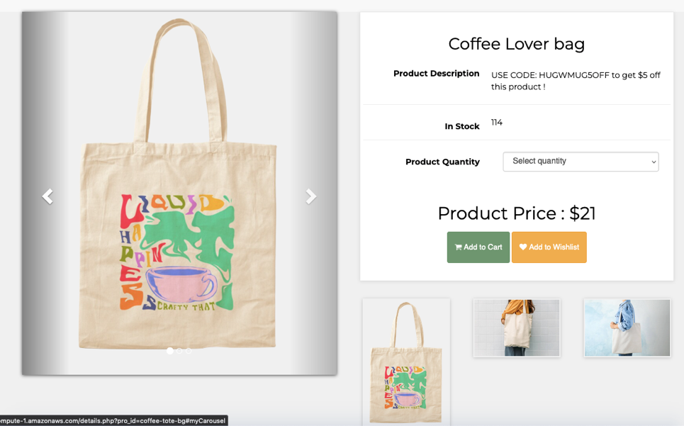Our product display/details page displays all the information about a single product. Depending on the “product URL” stored in our products database table, we will display the corresponding products title, description, quantity in stock, a form selection for the user to select the quantity they desire, the product price, the sale price (if on sale), the add to cart button, the add to wish list button, and 3 “recommended” products that the user may also click on. We also display the 3 product images for the corresponding product. These 3 images rotate amongst a carousel that the user can traverse through.

Snippet of *the product display page*, which the details surrounding a single product

**4b.06.01: Add to Wishlist**

Anytime a user is visiting a product’s display page, they have the option to add the product to a wish list. If the user is not signed in, but clicks “add to wish list”, they will be redirected to login with their account credentials. If the user is signed in, they will be notified that the product was added successfully. Then, the user may see the product in their wish list by visiting the ‘my wish list’ page, located in account settings. From there, they can see an image of the product, the product title, and they even have the option to delete the product from the list. This functionality 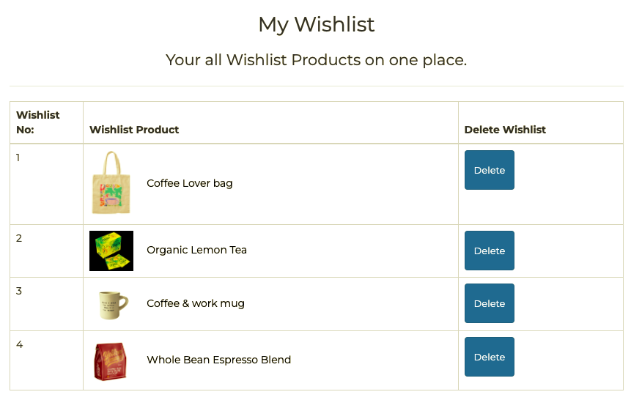interacts with the wish list table in the database.

Snippet of *the ‘my wish list’ page*, which lists the products stored in a customer’s wish list

**4b.07.01: My Account Features**

Once a user is logged in, they will be able to access a link to different account features through the “my account” drop down menu. The user can view a list of all their placed orders- which gets its information from the customer_orders database table. They can change their password, they can view their wish list, they can edit their account, and they can log out all through this setting page.

**4b.07.02: My Wishlist Page**

As talked about previously, the user can view their wish list saves on this page. This page is accessible through the account settings drop down menu or sidebar.

**4b.07.03: View Orders Page**

The user can view a list of all their placed orders- which gets its information from the customer_orders database table.

This list displays a list of product purchases, their corresponding order/invoice number, the quantity purchased, and the order date.

**4b.07.04: Edit Account Page**

The user can edit their account. Their account information will be in a pre-filled form, then they can edit this information to their liking, then submit the changes. After the submission, the user will be prompted to log into their account again.

**4b.07.05: Change Password Page**

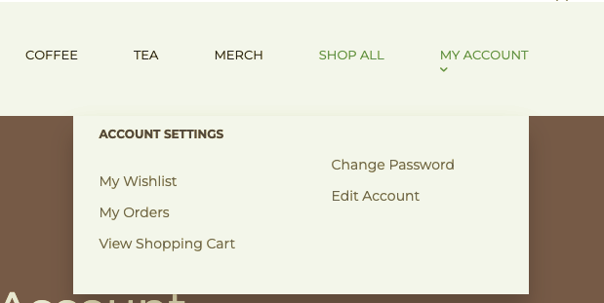Here, the user can easily change their password. Once submitted, the new password will be stored in the customers database for that existing user. Then, the user will be prompted to log in again.

Snippet of *the ‘account settings’ drop-down menu*



Gif of *the account settings panel*, which is where a user can access various account features

**4b.08.01: Add to Cart Functionality + Order Summary**

When the user is on the product’s display page, they have the option to add the product to their cart. They can add to their cart even if they are not signed in, but they will eventually have to sign-in to checkout. When the user “adds to cart”, we are updating the cart database table which will store the products added, their quantity, and an ip address which corresponds to the user’s ip. To visit their shopping cart, a user can click on the cart icon on the top right of the homepage. The shopping cart page will display the products that the user has added, as well as other product information that is found in the products database. This cart table will display the products image, title, quantity selected, price, total, and an option to select the product for deletion.

There is also a **discount code** option which will apply to certain products enabled for discounts.

* + For example, “HUGWMUG5OFF” will take 5 dollars off the “coffee lover bag”.

There is also an order summary, which displays the true calculated total that the user will “pay” for at checkout (subtotal + tax + shipping (- discount)).

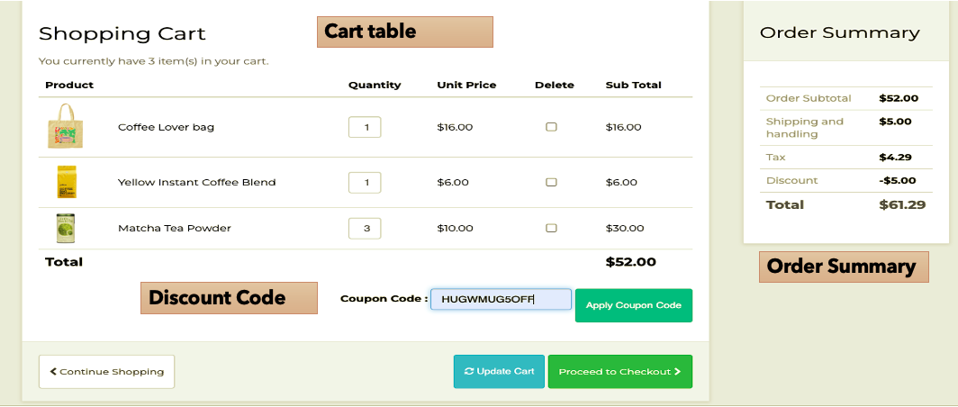

Snippet of *the ‘cart’ page*, which lists the products the customer has added to their shopping cart.

**4b.09.01: Placing the Order**

Once a user is signed in, and they have products in their cart. They will be able to “proceed to checkout”. From there, they can view the payment options available, then click to place their order. Once the order is placed, the customer_order database table is updated with the customer’s order, and the user will be notified that their order was successfully placed. They can then visit the details of their order in their account settings 🡪 view orders.

Gif of *the ‘proceeding to checkout’,* which is how orders are placed & saved to the DB.

**4b.10.01: Search**

The search engine works as a function for the user to search for a specific product or anything related to the website. The user can search for things such as coffee, tea, and merchandise products.

The user can type into the search box located on the home page and click the “search” button. After the “search” button is clicked it will display the search results to the user if any keywords are matched from the database. If no matches are found, then the search feature will ask the user to search again. The results that will be displayed will depend on the matching keywords.

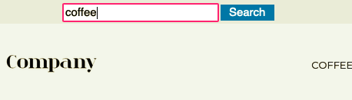For example: if the user searches for coffee, then the search feature will display the results found for “coffee”, the keyword “coffee”, and a functioning link that the user can click on to be directed to the web page related to the search.

Snippet of *the search bar*

**Part 4c: Functionality: Admin Experience:-**

*To demo this experience, Just visit* [*our admin panel*](http://ec2-54-172-16-142.compute-1.amazonaws.com/admin_area) *and login with:*

*username: admin@mail.com | password: Password@123*

**4c.01.01: Admin Login**

If an admin user wants to visit the admin backend panel, they can do so by visiting url/admin_area. From there, they will be prompted to log in with their admin credentials. The credentials entered are cross checked with the admin database table. If the credentials entered match with what is in the database, then the admin user can successfully access the admin panel. If not, the admin will be prompted to try logging in again.

**4c.02.01: Admin Panel**

The admin panel is the homepage for the admin user. It is the page the admin immediately sees as they are logged in.

**4c.02.02: Admin Panel: Dashboard**

This dashboard conveniently displays important information for the admin. It displays the number of products currently for sale, the number of customers, the number of categories of the products, the number of orders currently placed, the total amount of money earned, and the total number of coupon codes currently available to use. Within each of these blocks, the admin can click to view more details, which will take them to their perspective pages. At the bottom of the dashboard, the admin can readily see the most recent orders placed by customers.

**4c.02.03: Admin Panel: Sidebar**

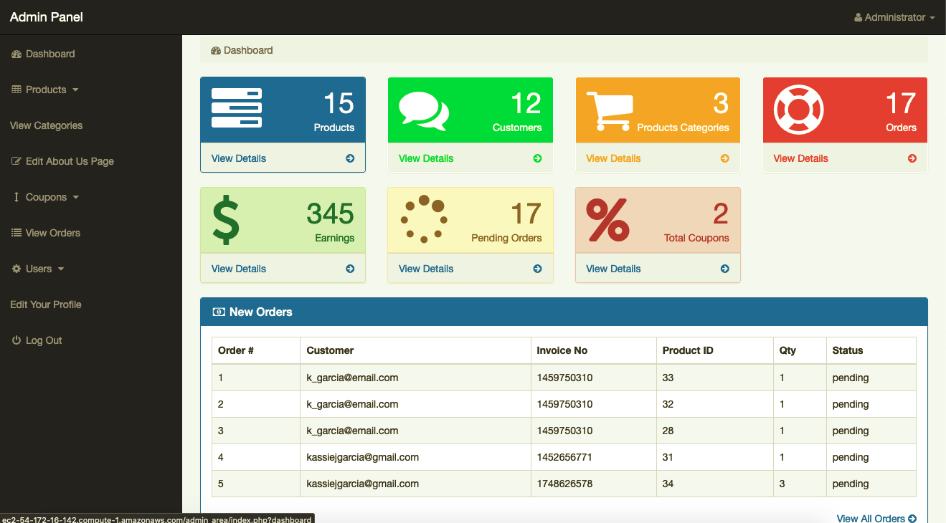This sidebar is where the admin user can access *all* the admin features- such as viewing / inserting / editing products for sale, viewing orders, and more!

Snippet of the *admin panel*, where the *sidebar* is on the left, and the *dashboard* is the main page on the right

**4c.03.01: Admin_Area Products**

From the admin panel sidebar, the user can access the products section. In this section, the admin user has the option to either visit the insert products page or the view products page.

**4c.03.02: Insert a new Product**

From this page, the admin user can easily insert new products to be displayed on the website. The page takes in the products title, url, category, 3 images, price, sale price, keywords, quantity, description, and a label which will indicate if the product is on sale or not. If all the input is correct, the images will be uploaded to our image directory, and the information will all be entered into the products database table. Then, the admin user will be notified of its success, and can immediately see the newly added product in the product list and in the shop pages. If there was an error, the admin user will be notified to try again.

**4c.03.03: View List of Products for sale**

From this page, the admin user can view all the products that are currently for sale on the website. The list displays the product information from the product database table, such as: product title, product first image, price, number sold, keywords, date added, quantity, and links to either *delete the item* or to *edit / modify the item*.

**4c.03.04: Modify an existing Product**

Through the view product page, the admin user can select to “edit” a product. This link will take them to the modify product page. From this page, the form will pre-fill with all the product information currently stored in the products database table. Once a change is made, the admin user can click to update the product and will be notified if that update was successful. These updates will be immediately reflected in the list of products as well as on the website directly.

Gif showcasing the functionality of *viewing the listed products & updating a single product*

**4c.04.01: Admin_area View Categories**

An admin user can click on the categories section of the panel sidebar to visit the view categories page. This page simply displays the categories in use (located in the categories database table) and includes the option to delete these categories as well.

**4c.05.01: Admin_area Edit the About Us Page**

The admin user can click on the edit about us page from the panel sidebar to visit the edit page. This page will contain a form which will prefill with the “about us” data stored in the about_us database table. From here, the user can make changes to this “about us” description (which is displayed in the “about us” link located in the website’s footer) and update the database.

**4c.06.01: Admin_area Coupon / Discount Codes**

From the admin panel sidebar, the user can access the coupons section. In this section, the admin user has the option to either visit the insert coupon page or the view coupons page.

**4c.06.02: Insert a new Coupon / Discount Code**

In this page, the admin user can create a new coupon for the website. This page will take in the coupon title, the amount that should be taken off, the code, the usage limit to the code, and a selection box to select which product this code should apply to. If there are no errors, the code information will be stored in the coupons database table and will be ready for usage.

**4c.06.03: View the list of Coupons / Discount Codes**

From this page, the admin user can view all the coupon codes available for customers to use. The list displays the coupon title, product it applies to, price off, code, limit, how many times it has been used, an option to delete the coupon code, and an option to edit the coupon code.

**4c.06.04: Modify an existing Coupon / Discount Code**

Through the view coupon page, the admin user can select to “edit” a coupon. This link will take them to the edit coupon page. From this page, the form will pre-fill with all the coupon information currently stored in the coupon database table. Once a change is made, the admin user can click to update the coupon and will be notified if that update was successful. These changes will be automatically reflected onto the lists of coupons enabled and can be used immediately on the website itself.

Gif showcasing the functionality of *viewing the listed coupon & making changes to a selected coupon*

**4c.07.01: Admin_area Viewing Customer Orders**

From the admin panel sidebar, the user can access the view orders page. In this page, the admin user can see a list of all the currently placed orders from all customers. This list displays the order’s customer, the invoice / order number, the product ordered, the quantity of the product ordered, the date the order was placed, the total amount spent on the product ordered, the order status, and an option to delete the order from the customer_orders database.

**4c.06.02: Sorting Customer Orders**

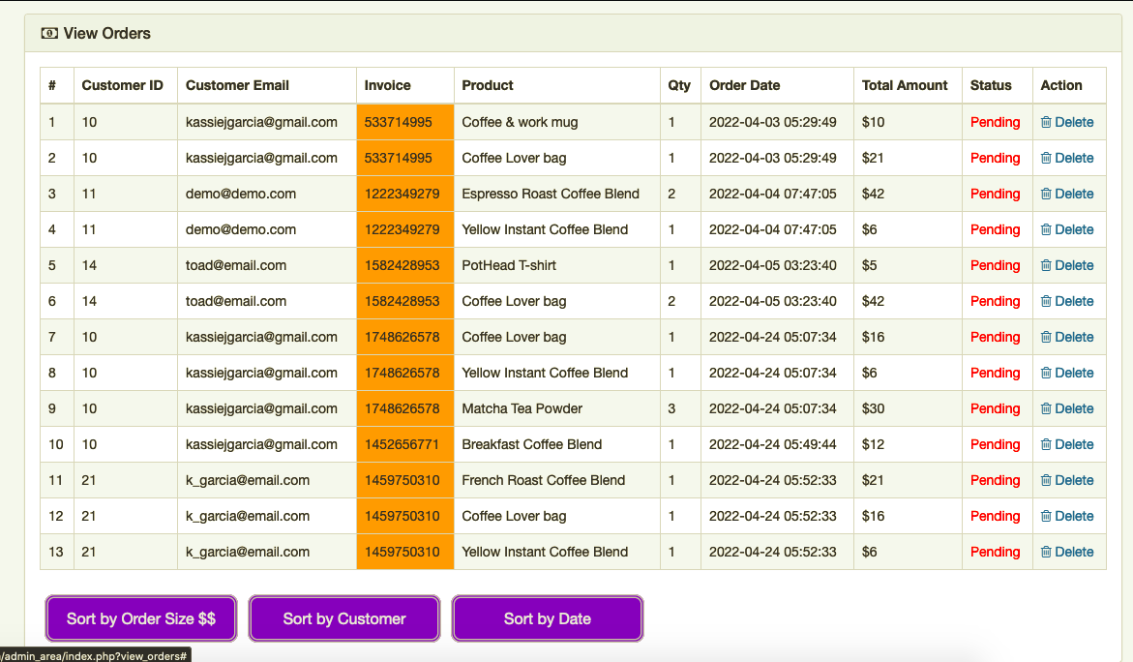In this order page, the admin user can sort the orders either by the order size (dollar amount), the order date, or by the customer in alphabetical order. All the admin users must do is click on the sort buttons at the bottom of the list and they can sort how they please.

snippet which shows the *list of placed orders* as well as the *sort buttons* which can sort the orders by different options

**4c.07.01: Admin_area Users**

From the admin panel sidebar, the user can access the ‘users’ section (customers). In this section, the admin user has the option to either visit the insert users page or the view user page.

**4c.07.02: Insert a new User**

In this page, the admin user can insert a new user for the website. The admin user must enter a name, username, email, password, address, and contact info correctly. If the information entered is correct, the customers database table will be updated with a brand-new user inserted and the admin user will be notified of its success.

**4c.07.03: View List of Users**

In this page, the admin user can view a list of users with displays a user’s name, username, email, address, and phone number. There are also 2 options to either delete the user from the customers database table or to edit the user via edit user page.

**4c.07.04: Modify an User**

Through the view users page, the admin user can select to “edit” a user. This link will take them to the modify user page. From this page, the form will pre-fill with all the user information currently stored in the customer database table. Once a change is made, the admin user can click to update the user and will be notified if that update was successful. Any changes will be automatically reflected in the list of users.

Gif which showcases the *list of customers (users)* as well as *modifying* a single user named frog

**4c.08.01: Edit Your Admin Profile**

From the admin panel sidebar, the admin user can access the edit your profile page. In this page, the admin user can edit their own profile and update their changes to the admins database table. The admin user will be notified if their changes were successful. And will be prompted to sign in again.

**Part 5: Conclusion:-** In this project, there was a lot for everyone to learn- and we definitely had our highs and our lows as a group. In some meetings, we would have great communication and collaboration. In other meetings, barely anyone would show up or contribute towards the sprint goals. It was difficult, but in the end, we learned a great deal about self-discipline. We learned that as computer scientists, we should be able to handle a wide variety of tasks, no matter the programming language(s) we must learn. So, even though the majority of the group started off not knowing anything about web development, we were able to learn and handle developing in brand new languages- and we became better computer scientists because of it.

All in all, we achieved our goal of creating a web application dedicated to the Hug With Mug shopping experience, and we are all immensely proud of the work we have put into this project.

**Part 6: Relevant Links:-** Below, we have listed important links related to our project.

**GitHub Repository:** <https://github.com/kassiejgarcia/Software-Engineering-Project>

**Website URL:** <http://ec2-54-172-16-142.compute-1.amazonaws.com/shop.php>

**Website Customer Login:** <http://ec2-54-172-16-142.compute-1.amazonaws.com/checkout.php>

Username: hamtaro Password: UTSA2022se!

**Website Admin Login:** <http://ec2-54-172-16-142.compute-1.amazonaws.com/admin_area/login.php>

Username: [admin@mail.com](mailto:admin@mail.com) Password: Password@123

**Shared Google Folder:** <https://drive.google.com/drive/folders/1D6MyMsLhCdx8hKRCg7fmNKZWiWlOzuXh?usp=sharing>